






Tell us what you think about the Anti-Discrimination Act

www.lawreform.nsw.gov.au

About this information





This information is from the NSW Law Reform Commission.


The NSW Law Reform Commission gives advice to the NSW government about changing the law.

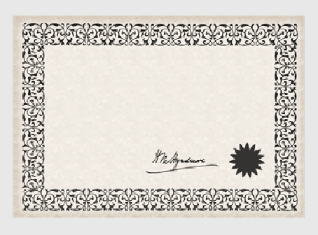
We are looking into a law called the

Anti- Discrimination Act

Anti-Discrimination Act.

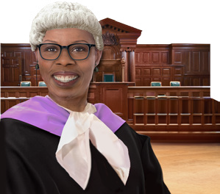
The Anti-Discrimination Act is a law about how people must be treated in a fair way.
We will say ADA for short.

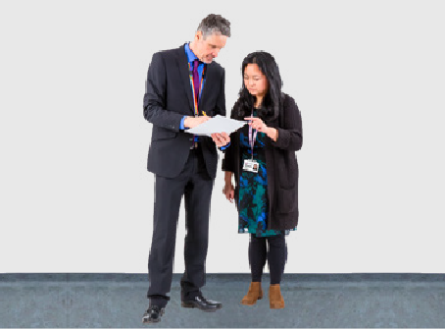
We want to find out if the government should make changes to the ADA.

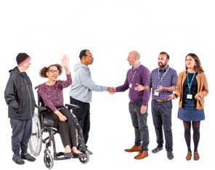
We will do this by speaking to lots of people.

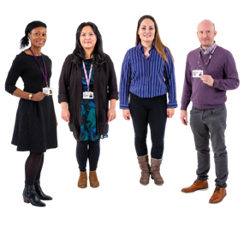
Then we will tell the government what we find out.


We would like to hear what you think about the ADA.

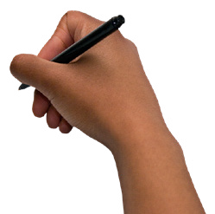
You can write your answers in the box under each question.


You can also email your answers. Send an email to

ADAreview@dcj.nsw.gov.au


This information might be hard to understand.

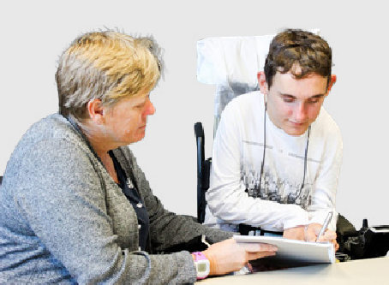
You can ask someone to support you to read it.

About discrimination


The ADA tries to stop 2 kinds of discrimination from happening.

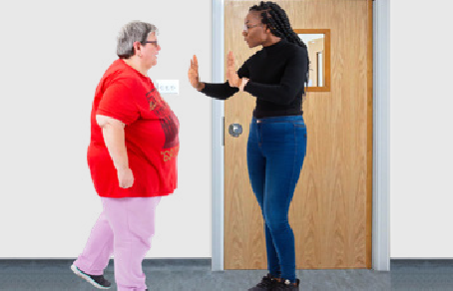
These are

- When someone treats you in a bad way because of who you are.


- Where there is one rule for everyone but it is unfair for some people.

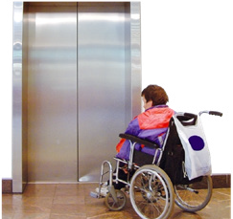

There might be a rule everyone has to work in a building with no lift.

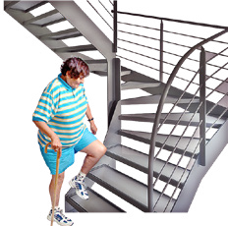
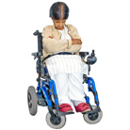
This would be unfair for someone who uses a wheelchair.

Question

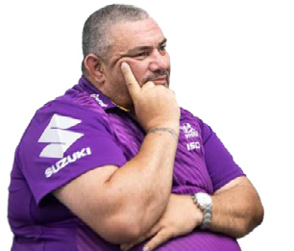
What do you think discrimination is?

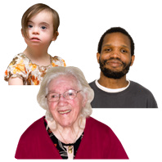
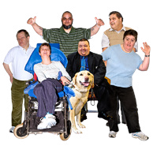

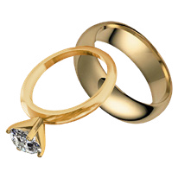
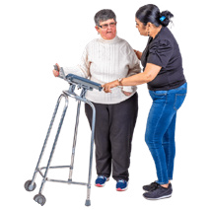
Who should be kept safe from discrimination?

The ADA says discrimination should not happen because of things like

- Your age

- Your disability

- If you are married or not

- Which country you are from

- If you are a carer for someone.


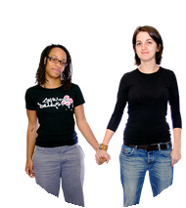
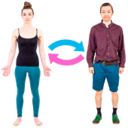
The ADA also says discrimination should not happen because you are

- Gay

- Lesbian

- Transgender.


Gay means men who have sexual feelings for other men.

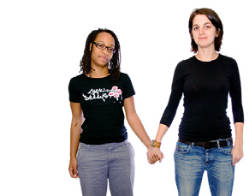
Lesbian means women who have sexual feelings for other women.

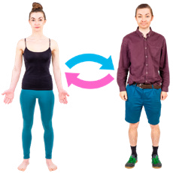
Transgender means people who feel different from the sex they were born.

Questions

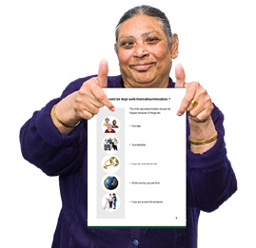
Should other groups of people be kept safe from discrimination?

Yes

No


If you said yes then what other groups?

When discrimination happens because of more than 1 thing


The ADA says when someone has had discrimination it is because of 1 thing about them.

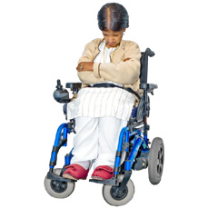
It might be that discrimination happens about their disability.

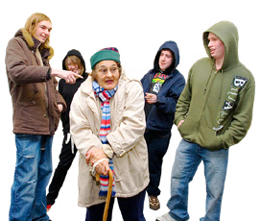
Some people can have discrimination happen to them because of more than 1 thing.

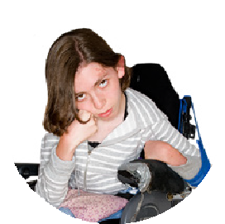
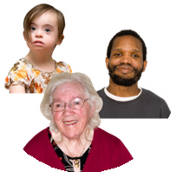
They might have discrimination happen because of things like their
- Disability

and

- Age.


Some people think this should also be in the ADA law.

Questions


Should the ADA say discrimination can happen because of more than 1 thing?

Yes

No


Why do you think that?


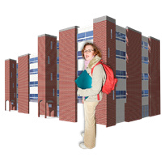



Where the law says discrimination can not happen

club

The ADA says discrimination should not happen in places like

- Work

- Where people learn things like at school

- Where people get and buy things

- Where people pay to live like a group home

- When they are a member of a club.

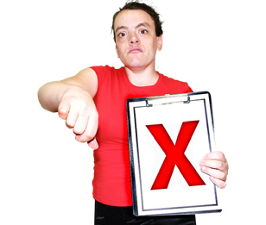
Sometimes discrimination is not against the ADA law.

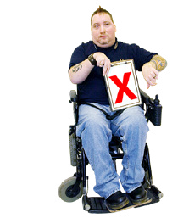
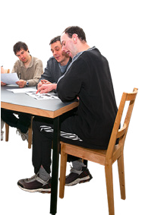
This might be if someone with a disability can not do something that is part of their job.



It might be if the support someone needs at work

- Costs too much money

- Is very hard for the business to do.

Questions



Should the ADA protect people from discrimination in any other places?

Yes

No

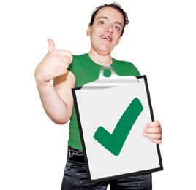
If you said yes then where?

Vilification

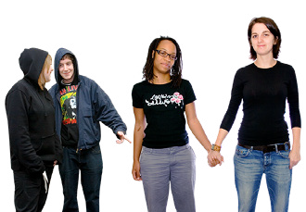
The ADA says vilification should not happen to some groups of people.

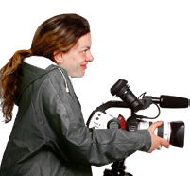
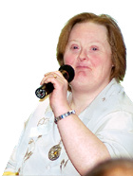
Vilification means when someone says or writes very bad things about someone else in public.


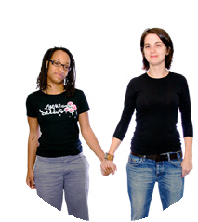
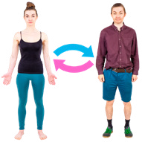
ADA says vilification is against the law if it is about being

- Gay

- Lesbian

- Transgender.

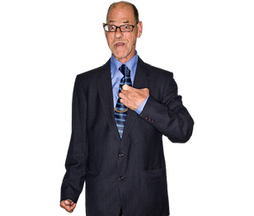

It also says vilification is against the law if it is about you having HIV or AIDS.

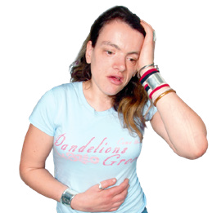
HIV and AIDS are blood diseases that can make people very sick.

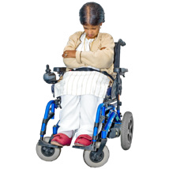
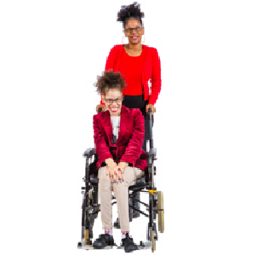
The ADA does not say vilification is against the law if it is about

- Your disability

- If you are a carer for someone.

Questions

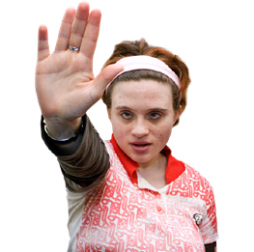
Should the ADA stop vilification about these groups of people

- People with disability

- Carers of people with disability


Any one else?

When the ADA says vilification happens

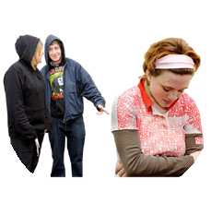
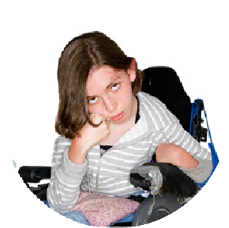
The ADA says it is vilification if a person does something in public that
- Tries to make others hate a person or group and
- Is for something about that person or group
like their disability.

Questions

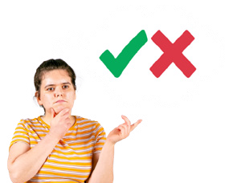
Do you think the ADA should say vilification happens in any other ways?
Yes

No

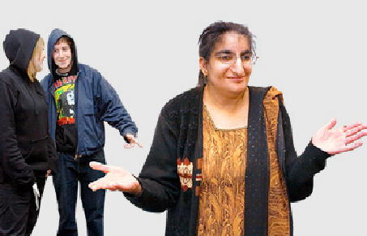
Why do you think this?

Sexual harassment

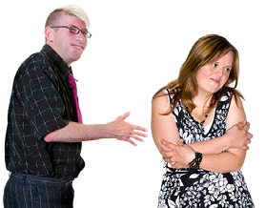

The ADA says sexual harassment is not allowed.

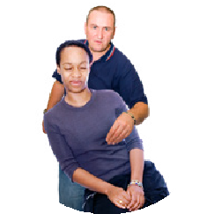
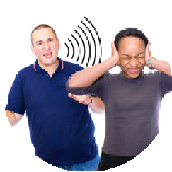
Sexual harassment is when someone

- Does sexual things to someone who does not want it

- Says sexual words to someone who does not want it.

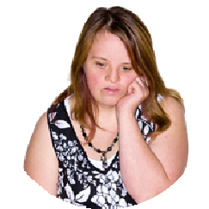

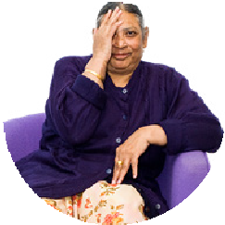
When these things happen the person might feel

- Sad

- Scared

- Embarrassed.



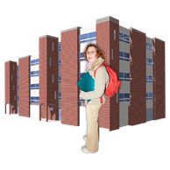


The ADA says sexual harassment should not happen in places like

- Work

- Where people learn like school

- Where people get and buy things

- When someone pays to live somewhere

- When someone plays sport in a team.


The ADA does not say sexual harassment is against the law in all places.

Questions


Should the ADA protect people from sexual harassment in any other places?

Yes

No

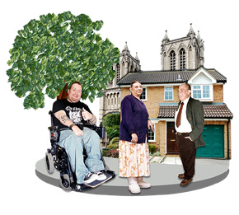
If you said yes then where?

ADA is only for sexual harassment

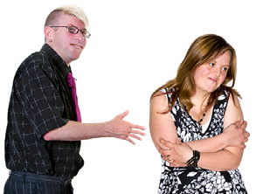
The ADA only keeps people safe against sexual harassment.

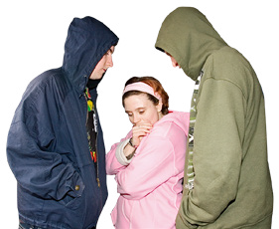
The ADA does not look after any other types of harassment like if it is about your disability.

Question

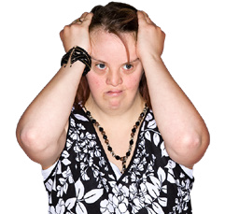
What other types of harassment should be in the ADA?

What you can do if you are treated badly

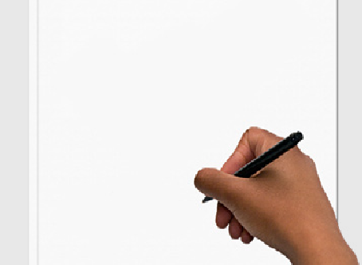

If you are treated badly you can make a

complaint to Anti-Discrimination NSW.

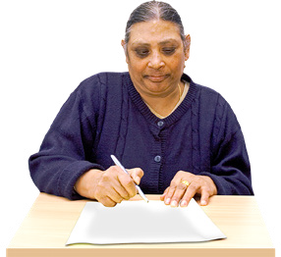
Complaint means you speak up about something bad that happened to you.


Anti-Discrimination NSW looks after all the complaints people make about the ADA.

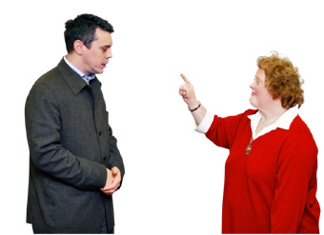
Anti-Discrimination NSW can then try to support the people to see if they can fix the problem together.


If they can not fix the problem the complaint can go to the NSW Civil and Administrative Tribunal.
We will say NCAT for short.

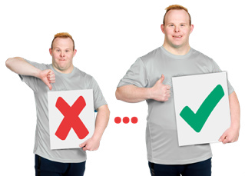
NCAT helps to decide what to do about complaints when people do not agree.

Question

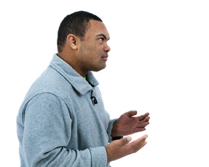
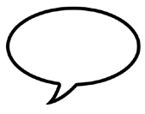
Do you have any stories that you want to share?
The stories could be about when you made a complaint about being treated in a bad way.

Get more support for people to make a complaint

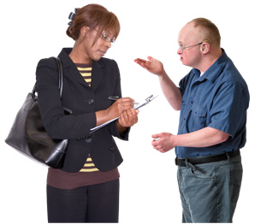
Some people say people should not have to make a complaint on their own.

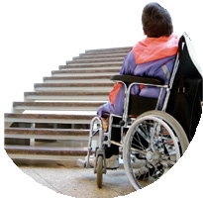

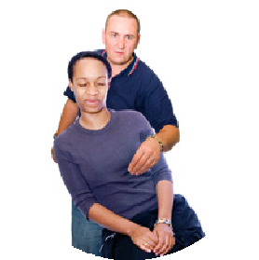
They say there should be an organisation that helps to stop
- Discrimination

- Vilification

- Sexual harassment.

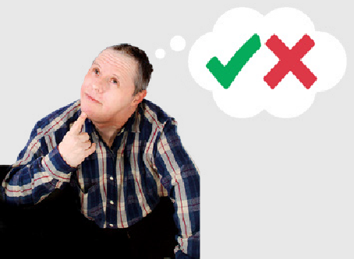
They say that the organisation should also help to fix the issue.


Some people say this organisation should keep groups of people safe.

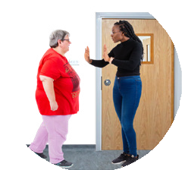

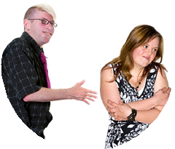
Some people think bosses at jobs should need to do things in their workplace to stop

- Discrimination

- Vilification

- Sexual harassment.

Question

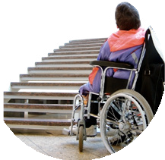

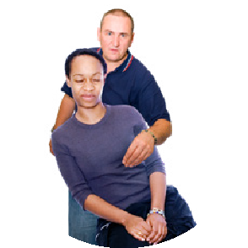
What else do you think can be done to help stop

- Discrimination

- Vilification

- Sexual harassment.

Council for Intellectual Disability made this document Easy Read. CID for short. Email CID at business@cid.org.au if you want to use any of the pictures.

